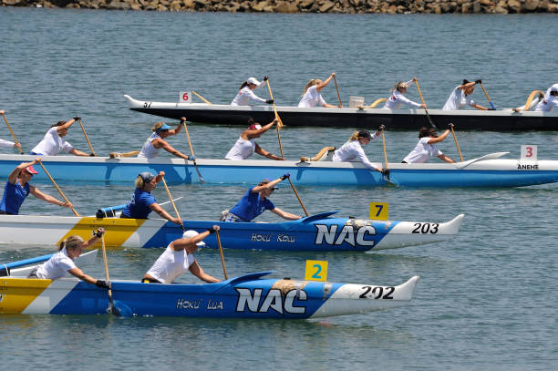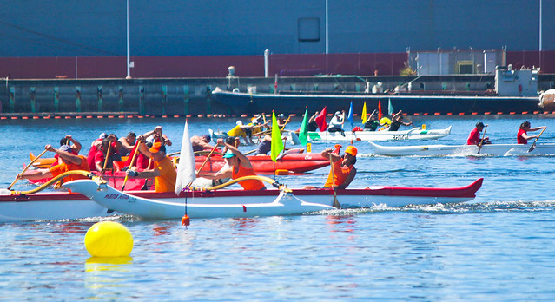
ATTENTION ALL OUTRIGGER AND DRAGON BOAT PADDLERS
YOU ARE INVITED TO REPRESENT THE UNITED STATES as part of a PNW regional crew IN THE 2026 IVF WORLD OUTRIGGER SPRINTS IN SINGAPORE, AUGUST 2026
TRAINING BEGINS: August 2025 in Portland, Oregon. U.S. qualifying race will be October 2025 on Vancouver Lake, WA
All Gender and Age Categories will train in Portland with water trainings, gym and nutrition training, plus guest speakers.
If you have questions and are interested, please contact: Diane Kadolph-Ray, zambopdx@gmail.com, 503-369-8625. Once names are collected
there will be a meeting in August to go over schedules, expectations, costs, and possibilities. Keep paddling and training with your current crews.